MOAC Access Circling Back 3

As Woodgrove Real Estate grows, you continue to learn more about Access and use the database for more advanced tasks.

CB3 - Project 1: Create a Grouped Report
You want to see the houses that have been sold each month. Use the Report Wizard to create a report that groups the data according to the closing date. Then create an aggregate field that will sum the total amount of sales for each month.

GET READY. Launch Access if it is not already running.
- OPEN the Woodgrove Real Estate database from the data files for this lesson.
- SAVE the database as Woodgrove Real Estate XXX (where XXX is your initials).
- OPEN the Houses Sold table.
- On the CREATE tab, in the Reports group, click the Report Wizard button to display the first screen in the Report Wizard.
- Select the Listing Agent field and click the single right arrow to move the field to the Selected Fields list.
- Using the same method, move the Address, Selling Price, and Closing Date fields from the Available Fields list to the Selected Fields list.
- Click the Next > button to display the second screen in the Report Wizard.
- Select the Closing Date field and click the single right arrow to move it to the grouping levels box.
- Click the Next > button to display the third screen in the Report Wizard.
- Click the down arrow on the Sort menu and select Closing Date.
- Click the Next > button to display the fourth screen in the Report Wizard.
- In the Layout section, the Stepped option button should be selected and in the Orientation section Portrait should be selected.
- Click the Next > button to display the fifth screen in the Report Wizard.
- Click the Finish button to accept the settings and create the report.
- CLOSE Print Preview.
- Switch to Layout view.
- Right-click the first cell under the Selling Price header to display the shortcut menu.
- Click Total Selling Price and then click Sum. The totals for each month are displayed. Resize the controls, if necessary, so all the labels and data can be read. Your report should look similar to Figure 1.

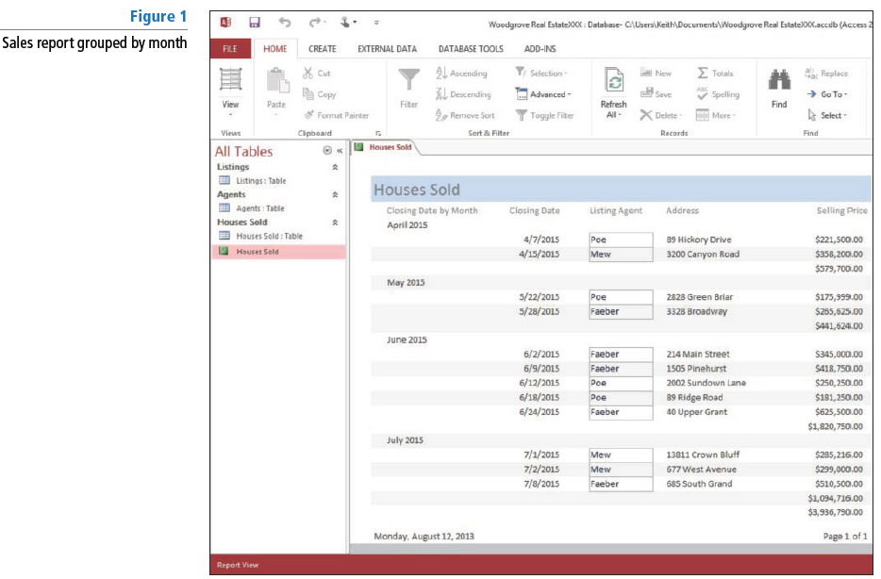

- SAVE and CLOSE the report.

PAUSE. LEAVE the database open to use in the next project.

CB3 - Project 2: Create a Calculated Query Field
You are interested in knowing the difference between each house’s asking price and selling price. Create a query with a calculated field that will give you this information. Then add a Total row so you can find the average asking price, selling price, and difference.

USE the database that is open from the previous project.
- On the CREATE tab, in the Queries group, click Query Design.
- In the Show Table dialog box, double-click Houses Sold to add the table to the design grid.
- Select the Houses Sold table in the Navigation Pane.
- In the Houses Sold field list, double-click Address, Bedrooms, Bathrooms, Asking Price, and Selling Price.
- Click the Field cell in the first blank column and press Shift 1 F2 to open the Zoom dialog box.
- In the Zoom dialog box, key the following expression:
Difference: [Asking Price] - [Selling Price]
- Click OK.
- On the DESIGN tab, in the Results group, click Run to create a query with the new calculated Difference field.
- On the HOME tab, in the Records group, click the Totals button. Notice the Total row at the bottom of the result set.
- In the Asking Price field, click the Total cell down arrow to display the menu and click Average.
- In the Selling Price field, click the Total row down arrow and click Average.
- In the Difference field, click the Total row down arrow and click Average. Your query should look similar to Figure 2.

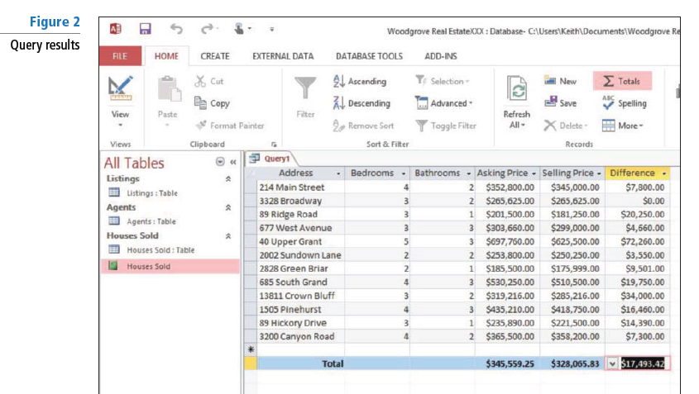

- SAVE the query as Price Difference Query and close the query.

PAUSE. LEAVE the database open for the next project.

CB3 - Project 3: Create a Chart
In the report you created, you want to have a pictorial view of the data along with the numbers. Use the Chart Wizard to insert a 3-D column chart into your existing report.

USE the database that is open from the previous project.
- OPEN the Houses Sold report.
- Switch to Design view.
- On the DESIGN tab, in the Controls group, click the Chart button. The pointer changes to a plus sign with a chart icon.
- Click in the upper-left corner of the Page Footer section and drag to the lower-right corner to create a rectangular placeholder where the chart will be inserted.
- Release the mouse button. The first Chart Wizard dialog box appears.
- Select the Houses Sold table as your data source and click the Next > button. The second Chart Wizard dialog box appears.
- Double-click the Asking Price, Selling Price, and Closing Date fields to move them to the Fields for Chart box and click the Next > button. The third Chart Wizard dialog box appears.
- Click the 3-D Column Chart button, the second icon in the first row.
- Click the Next > button. The fourth Chart Wizard dialog box appears.
- Click and drag the Selling Price field button to the upper-left of the chart and drop it just below the SumofAskingPrice data list. Both the SumofAskingPrice and SumofSellingPrice fields should be listed.
- Click the Preview Chart button. The Sample Preview dialog box appears, displaying a sample of your chart.
- Click the Close button. The Sample Preview dialog box closes.
- Click the Next > button. The fifth Chart Wizard dialog box appears.
- Click the Report Fields down arrow and in the menu select <No Field>.
- Click the Chart Fields down arrow and in the menu select <No Field>.
- Click the Next > button. The sixth Chart Wizard dialog box appears.
- Key Summer 2015 in the Title box.
- The Yes, display a legend button should be selected. If not, select it and click the Finish button. Access inserts your chart.
- Click the chart to select it and resize it appropriately. Move the Date and Page # controls below the chart, if necessary.
- On the DESIGN tab, in the Tools group, click the Property Sheet button.
- Click the DATA tab of the Property Sheet. Click the down arrow at the end of the Enabled line and select Yes.
- CLOSE the Property Sheet.
- Switch to Report view.
- On the HOME tab, in the Records group, click the Refresh All button.
- Scroll to the bottom of the report to view your chart, which should look similar to Figure 3.

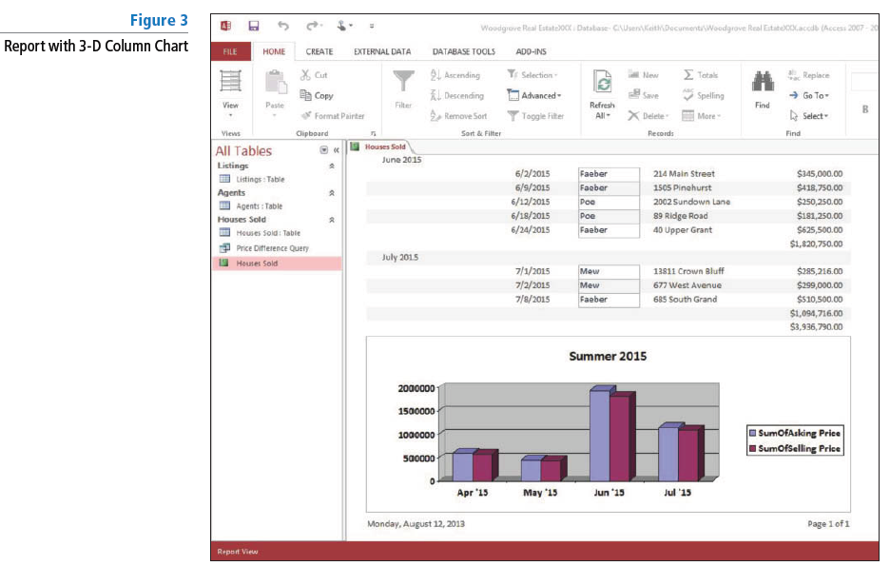

- SAVE and CLOSE the report.

PAUSE. LEAVE the database open for the next project.

CB3 - Project 4: Export Data and Save Specification
You need to provide listing information to the agents in your office in another format, so you export the data to Excel. Because you will perform this export operation on a regular basis, you save the specification for future use.

USE the database that is open from the previous project.
- In the Navigation Pane, select the Listings: Table.
- On the EXTERNAL DATA tab, in the Export group, click Excel. The Export – Excel Spreadsheet dialog box appears.
- If you want to specify a different destination for the data you want to export, click Browse to open the File Save dialog box, choose a folder, and then click Save.
- Click the Export data with formatting and layout checkbox and then click the Open the destination file after the export operation is complete checkbox.
- Click OK. Excel opens and the new worksheet with exported data is displayed.
- CLOSE the worksheet and CLOSE Excel.
- Switch to Access.
- On the Save Export Steps screen, click the Save export steps checkbox to display the specification details.
- In the Description box, key Export listing information to Excel. Click Save Export.

PAUSE. LEAVE the database open for the next project.

CB3 - Project 5: Maintain, Back Up, and Split a Database
You regularly perform routine maintenance on the database to ensure data integrity. You decide to split the database into two files to reduce network traffic, but after all the work you have put into the database you first want to protect your work by backing it up to prevent data loss.

USE the database that is open from the previous project.
- Click the FILE tab, and click Compact & Repair Database on the Info menu. Access compacts and repairs the database.
- Click the Save As tab on the FILE tab and in the Advanced category, click Back Up Database, then click the Save As button to display the Save As dialog box. Access automatically adds the current date to the end of the filename.
- Navigate to the location where you want to save the backed-up database then click the Save button to accept the generated filename and save the database.
- On the DATABASE TOOLS tab, in the Move Data group, click the Access Database button to display the Database Splitter Wizard.
- Click the Split Database button to display the Create Back-end Database dialog box.
- Navigate to the location where you want to save the back-end file and click Split. The Database Splitter dialog box appears.
- Click OK.
- CLOSE the database.
- OPEN Woodgrove Real Estate XXX_be. Notice that it contains only the tables for the database.
- CLOSE the database

STOP. CLOSE Access.

