MOAC Access Circling Back 1 (after L5)

Circling Back

You are a real estate agent and have recently opened your own office—Woodgrove Real Estate— with several other licensed agents. Because you are the one who is most knowledgeable about computers, you will be responsible for keeping track of the listings and other relevant information. You will use Access to begin developing the database that will be used by everyone in the office.

CB 1 - Project 1: Create a Database and Tables
After sketching out a plan on paper, you are ready to begin creating the database and tables.
GET READY. Launch Access if it is not already running.
- Near the center of the screen, click the Blank desktop database icon.
- In the File Name box, key WoodgroveXXX (where XXX is your initials).
- Click the folder icon and browse to the location where you want to store the file.
- Click the Create button to create a new blank database.
- Click Click to Add and click Short Text on the shortcut menu.
- Key Address as the column name and press Enter.
- Add new Short Text columns named Bedrooms, Bathrooms, Square Feet, and Price.
- Click the FILE tab and click Save.
- In the Save As dialog box, key Listings as the table name and click OK.
- On the CREATE tab, in the Templates group, click the Application Parts button, and click Contacts to create a new table. Click Yes, if necessary, to close and save the Listings table, then click Cancel in the Create Relationship dialog box that appears.
- Open the Contacts table.
- Right-click the Company field header and click Delete Field on the shortcut menu. Click Yes if you receive a dialog box warning you about the deletion.
- Delete the Job Title, Business Phone, Fax Number, Address, City, State/Province, ZIP/ Postal Code, Country/Region, Web Page, Notes, and Attachments columns. (If you get a message asking if you want to delete all indexes for the ZIP/Postal Code column, click Yes.)
- SAVE the table as Agents.
- Delete all the objects in your database except the Agents and Listings tables.

PAUSE. LEAVE the database open to use in the next project.

CB1 - Project 2: Modify Tables and Fields
Now that you have created the tables for your database, you need to modify them to suit your needs.

USE the database that is open from the previous project. The Agents table should be displayed.
- On the HOME tab, in the Views group, click the bottom portion of the View button and then click Design View.
- On the TABLE TOOLS DESIGN contextual tab, in the Show/Hide group, click Property Sheet.
- In the Property Sheet's Description property box, key Agent contact information.
- Click Close to CLOSE the property sheet.
- In the upper portion of the table design grid, click the EmailAddress field . In the field properties on the bottom, click in the Required property box and set it to Yes. In the field properties, click in the Default Value property box and key @woodgroverealestate.com.
- SAVE the table and switch back to Datasheet View.
- OPEN the Listings table. Place the insertion point in the Price column.
- On the TABLE TOOLS FIELDS contextual tab, in the Formatting group, click the down arrow in the Data Type box and click Number.
- In the Format box, click the down arrow and choose Currency.
- Change the data type/format on the Bedrooms, Bathrooms, and Square Feet fields to Number / General Number.
- Click the Click to Add column. Choose Attachment as the data type to create an attachment column.
- SAVE the table.

PAUSE. LEAVE the database open for the next project.

CB1 - Project 3: Create Forms and Enter Data
Now it is time to enter data into your database. First you create a form to make this task easier.

USE the database that is open from the previous project. The Listings table should be displayed.
- On the CREATE tab, in the Forms group, click the More Forms button.
- Click Datasheet to create a datasheet form.
- Click the FILE tab and click Save.
- In the Save As dialog box, key Listings as the form name and click OK.
- Use the form to enter data into the Listings table, as shown in Figure 1.

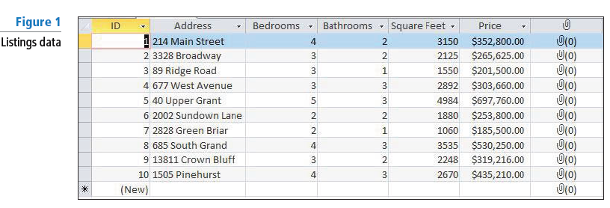
- Display the Agents table.
- On the CREATE tab, in the Forms group, click the Form button.
- SAVE the form as Agents.
- Switch to Form View and use the form to enter the data shown in Figure 2.

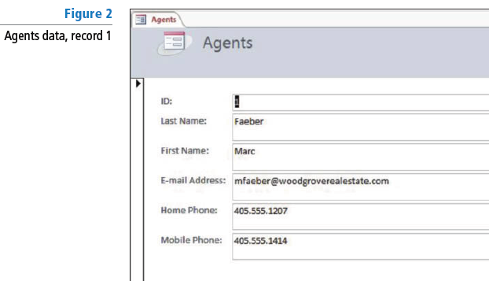

- Click the Next record button on the record navigator.
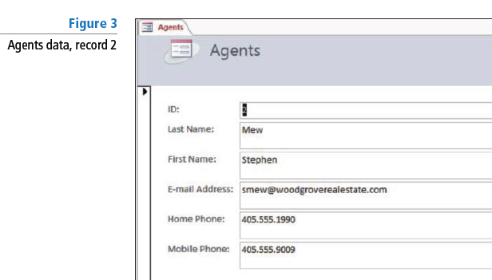
- Enter the data shown in Figure 3 as the second record.

- Enter the data shown in Figure 4 as the third record.

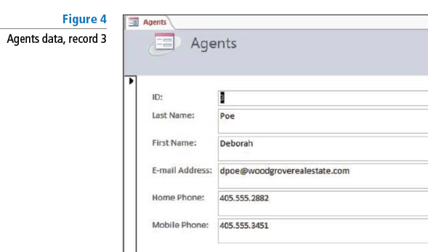
- CLOSE the Agents form and the Listings form.

PAUSE. LEAVE the database open for the next project.

CB1 - Project 4: Add Attachments and Create a Lookup Field
You have begun to use the database and realize it would be helpful for the Listings table to include the listing agent. Create a lookup field with this information and attach photos for some of the houses.

USE the database that is open from the previous project.
- In the Listings table, double-click the Attachment field for the fourth record (677 West Avenue).
- In the Attachments dialog box, click Add.
- Navigate to the data files for this lesson, select 677_West_Avenue, and click Open.
- In the Attachments dialog box, click OK.
- Attach the photo named 2002_Sundown_Lane to the sixth record.
- In the Listings table, place the insertion point in the cell under the Click to Add column.
- On the TABLE TOOLS FIELDS contextual tab in the Add & Delete group, click the More Fields button. Click the Lookup & Relationship command.
- Click Next > twice.
- Click Last Name and then click the > button to move it to the Selected Fields box.
- Click Next > three times.
- Key Listing Agent as the title for your lookup column.

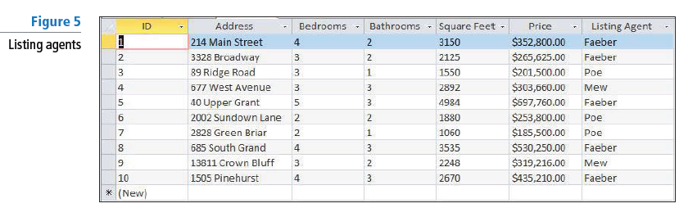

- CLOSE the form.

STOP. CLOSE the database.

