MOAC Access Circling Back 2 (after 10)

Circling Back

Woodgrove Real Estate is growing and adding more listings. Your office has added another real estate agent and has begun listing commercial properties as well as residential ones. The database you created has been a great way to keep track of all the listings and other relevant information. As you learn more about Access, you begin using it for a wider variety of tasks.

CB2 Project 1: Create and Format a Report
You want to create a report to display data about each agent’s listings. Use the Report Wizard and then switch to Design view to make changes to the format and add a control.

GET READY. Launch Access if it is not already running.
- OPEN the Real Estate database from the data files for this lesson.
- SAVE the database as Real EstateXXX (where XXX is your initials).
- On the CREATE tab, in the Reports group, click the Report Wizard button.
- In the Tables/Queries menu, choose Table: Listings.
- Click the double right arrow >> button to move all the fields into the Selected Fields list.
- Click the ID field to select it and click the left arrow < button to move it back to the Available Fields list.
- Click the Next > button.
- Click the Listing Agent field to select it and click the > button to add it as a grouping level.
- Click the Next > button.
- Select Price from the fields menu to sort in ascending order and click the Next > button.
- In the Layout section, click the Outline button. In the Orientation section, click the Landscape button. Click Next.
- Key Listings Report as the title of the report.
- Click Finish to display the Listings Report.
- On the PRINT PREVIEW tab, in the Close Preview group, click the Close Print Preview button to display the report in Design view.
- In the Listing Agent Header section, click and drag the right border of the Listing Agent field to make it smaller.
- Continue clicking and dragging the borders of the remaining report fields to resize them so your report looks similar to the report displayed in Report View, as shown in Figure 1.

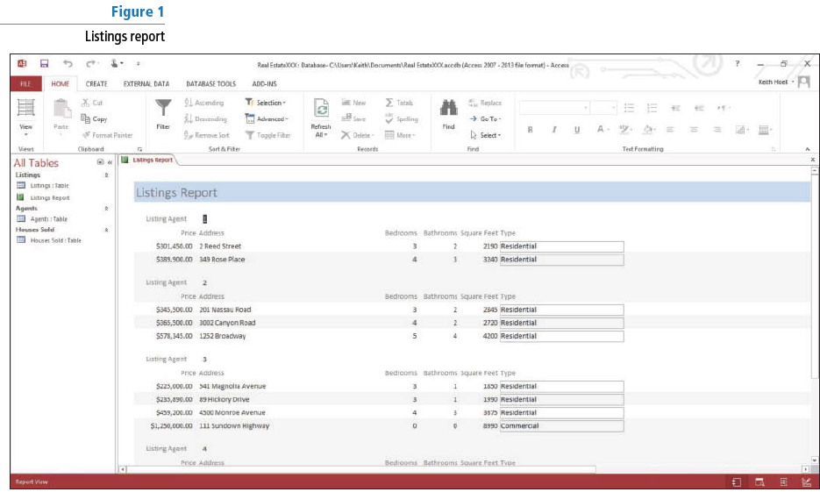
- Click the Close button on the Listings Report to close the report and save the changes when prompted.

PAUSE. LEAVE the database open to use in the next project.

CB2 Project 2: Create and Modify Queries

You want to query the database to find all the house sales that closed in June. Create a query using the Query Wizard and then add criteria to get the information you need.

USE the database that is open from the previous project.
- On the CREATE tab, in the Queries group, click the Query Wizard button to display the New Query dialog box.
- Click Simple Query Wizard and then click OK to display the Simple Query Wizard.
- In the Tables/Queries dropdown list, click Table: Houses Sold.
- Under Available Fields, double-click Listing Agent, Address, Selling Price, and Closing Date to move them to the Selected Fields box.
- Click the Next > button to display the next screen. Detail query should be selected.
- Click the Next > button to display the final screen.
- Click the Finish button to display the query.
- On the HOME tab, in the Views group, click the View button and click Design View.
- In the Criteria row of the Closing Date field, key Between #6/1/2014# And #6/30/2014#.
- On the DESIGN tab, in the Results group, click the lower half of the View button and click Datasheet View to display the query results of all records for houses that closed in June.
- Right-click the Closing Date field header and choose Sort Oldest to Newest on the menu. Your query should look similar to Figure 2.

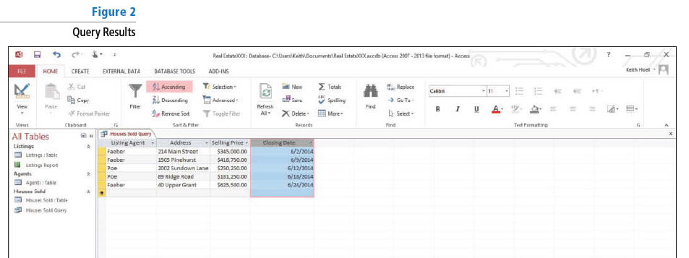

- Click the Close button on the Houses Sold Query to close the query. When prompted to save, click Yes.

PAUSE. LEAVE the database open for the next project.

CB2 Project 3: Sum Table Data

You want to know the total value of the current listings. Open the table and add a Total row to get this information.
USE the database that is open from the previous project.
- OPEN the Listings table.
- On the HOME tab, in the Records group, click the Totals button. The Total row appears below the asterisk (*) row.
- Click the down arrow in the Price column of the Total row. Select Sum from the menu. Your screen should look similar to Figure 3.

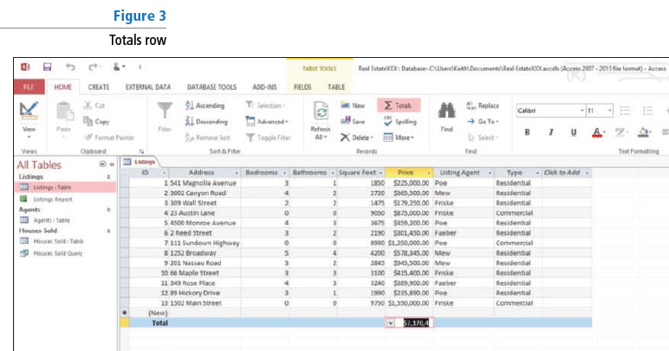

- On the HOME tab, in the Records group, click the Totals button to hide the Total row.
- On the HOME tab, in the Records group, click the Totals button again. The Total row reappears.
- SAVE and CLOSE the table.

PAUSE. LEAVE the database open for the next project.

CB2 Project 4: Create a Subform

You want to see the real estate agent’s contact information along with the listings. Use the Form Wizard to create a subform that will show all the data in the same place.

USE the database that is open from the previous project.
- On the CREATE tab, in the Forms group, click Form Wizard.
- In the first screen on the Form Wizard, click the Tables/Queries box down arrow and click Table: Agents.
- In the Available Fields box, double-click the Last Name, First Name, and Mobile Phone fields to move them to the Selected Fields box.
- Click the Tables/Queries box down arrow and click Table: Listings.
- In the Available Fields box, double-click the Address, Square Feet, and Price fields to move them to the Selected Fields box.
- Click Next >.
- In the How do you want to view your data? box, click by Agents. The Form with subform(s) option button should be selected.
- Click Next >.
- Click the Tabular option button to select that as the layout for your subform.
- Click Next >.
- Click the Finish button to create the Agents form with the Listings Subform. Your form should look similar to Figure 4.

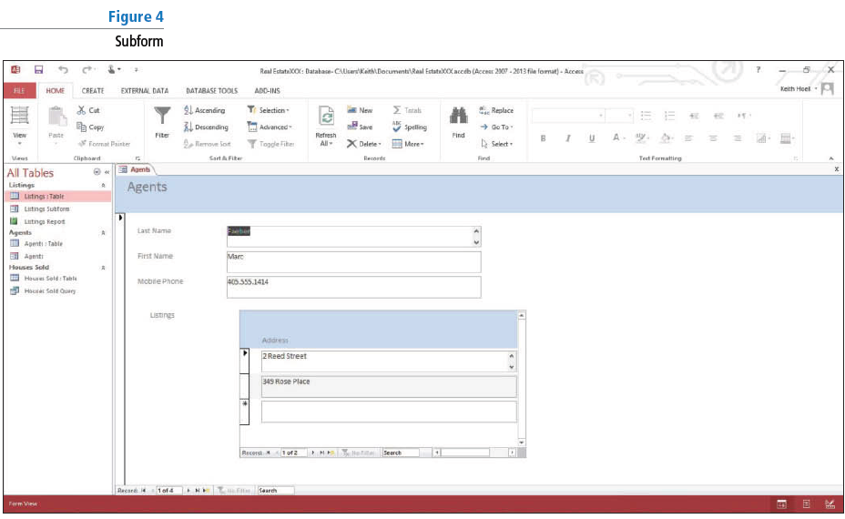

- In the Navigation Pane, double-click the Listings subform to open it.
- Scroll down to see the data contained in the records and then click the Close button on the Listings subform to close the subform.
- Click the Close button on the Agents form to close it.

STOP. CLOSE the database.

